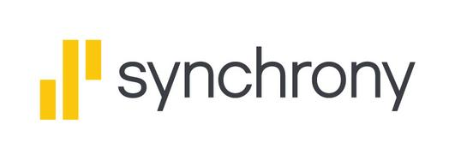
NEW CREDIT APPLICATION
Applicant Information
All fields are required unless otherwise noted

First Name MI Last Name
____________________________ ________________________ _________________________________________
Date of Birth Email Address Social Security Number or ITIN
____________________________ _______________________________ __________________________________________
Home Phone Business/Work Phone Mobile Phone
____________________________ __________________________ __________________________________________
Mailing Address Apartment (OPTIONAL)
_______________________________________________________________________ ______________________________
City State Zip Code
______________________________ ___________________________ _______________________________
Housing Status Monthly Net Income (from all sources)
____Own ___Rent ___other _____________________________________________
Primary ID Type Issuing State Exp. Date
Driver’s License ____ __________________________ ______________________________
Government Issued ID____
Green/Resident/Alien Card____
Military ID___
Passport ___
State issued ID___
Secondary ID Type Issuer Exp. Date
Credit Card _____ _______________________ __________________________
Other ____________________________

I ask Synchrony Bank (“SYNCB”) to issue me a SYNCB Credit Card (the “Card”) and I agree: To the SYNCB Credit Card agreement (“Agreement”). I am providing the information in this application to SYNCB and to merchants that accept the Card and program sponsors (and their respective affiliates), and I consent to SYNCBʼs providing information about me to merchants that accept the Card and program sponsors' (and their respective affiliates) for their own business purposes. SYNCB may obtain credit reports and other information, including employment and income, about me to evaluate my application and for other purposes. SYNCB, and any other owner or servicer of my account, may contact me about my account, including through text messages, automatic telephone dialing systems and/or artificial or prerecorded voice calls for informational, servicing or collection related communications, as provided in the Address/Phone Change and Consent To Communications provisions of the Agreement. I also agree to update my contact information. The Agreement will govern my account and includes: (1) a resolving a dispute with arbitration provision that limits my rights unless: (a) I reject the provision by following the provision's instructions or (b) I am covered by the Notice for Active Duty Military Members and their Dependents set forth in the Agreement; and (2) makes each applicant responsible for paying the entire amount of credit extended. Federal law requires Synchrony Bank to obtain, verify and record information that identifies applicants when opening an account. SYNCB will use applicants' name, address, date of birth, and other information for this purpose. If you apply with a Joint Applicant, each of you will be jointly and individually responsible for obligations under the Agreement and by signing below, you each agree that you intend to apply for joint credit. PLEASE SEE THE ATTACHED CREDIT CARD AGREEMENT FOR RATES, FEES & OTHER COST INFORMATION.

_________________________________________________________________ _________________________________________________
Applicant Signature Date

